“We” Photo Project Enrichment Activity
Directions: Phase 1
- Step 1: Get a photo from home!
  - The photo can be an original paper photo or a digital photo reproduced on regular paper.
  - The photo can be of just about anything as long as you are in it.
    - Examples include… birthdays, holidays, the beach, sports, hanging out with friends, dances, etc. etc. (have some fun sifting through your old photos!)
- Step 2: Fill out the photo analysis worksheet below. (Taken from USHMM)

- Step 3: Answer the following question
  - Why did you choose your particular photo?

Directions: Phase 2
- Step 1: Find your mirror photo
  - Follow the directions to find your mirror photo at the USHMM website.
    - Step 1: Go to www.ushmm.org
    - Step 2: In the top menu bar scroll over “Research” and click on “Collections and Archives”

    - Step 3: After clicking on Collections and Archives, you will be sent to a Research page. Look to the left hand side bar and click on “Photo Archives”.

    - Step 4: When you get to the Photo Archives page look towards the middle of the page for a blue link that says “Search Online Catalog” and click on it.
    - Step 5: In the search box, type in some key terms that you would derive from your family photo.
      - For Example: “friends hiking”
        - You might have to get creative with your searching… don’t give up!
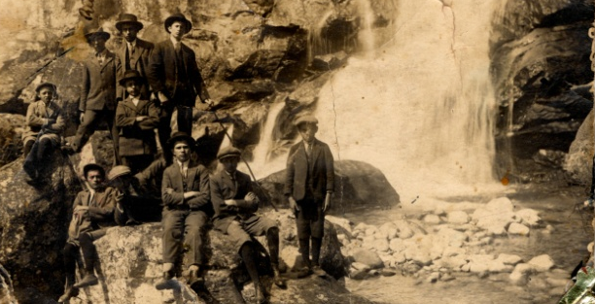
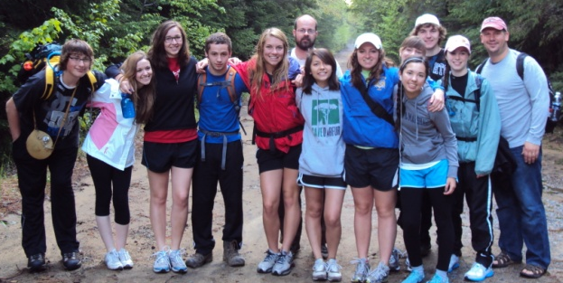

    - Step 6: Analyze your new photo using the same form as above
      - Under the photo from the USHMM site you will often times find a nice description of the photo and the people in it. This will help with analysis.

Directions: Phase 3
- Step 1: Answer the following question
  - What did you learn about the relationship between “you” and “them” via photographic analysis?
  - What are some of the similarities and differences between the photographs in terms of the subject matter?
  - As human beings, are we so different?

Directions: Phase 4
- Step 1: Presentation
  - This is really up to the teacher
  - You could have students make small posters with their pictures and analysis and display them around the room
  - You could have students make power point slides individually and then put them together into one class presentation
    - Students would have to digitize all photos if this is the route you decide to take
  - If a student is really into the project, encourage them to make an entire scrap book of family photos and mirrors
  - Make a movie using a movie making program
    - Use photos, text slides, and music that is appropriate
    - Again, photos will need to be digitized for this

The project is meant to be fun and allow for creativity while learning an important lesson. I usually break it up into two parts and I try to keep the kids in the dark as to what the final result will be. The kids turn in all Phase 1, 2, and 3 stuff, and I make the final part… usually some sort of movie. This often has a dramatic effect on the kids and the lesson hits home pretty well. But you are free to use the lesson as you see fit. Modify it to fit your needs, and have fun!

