Comparative Analysis Worksheet 2
- Topic: The Road to Genocide: Warning Signs
- Directions:
  - Based on your knowledge of the Holocaust and The Rwandan Genocide, please fill out the chart below regarding Warning Signs of Genocide
Please place a check mark next to the box if you know that the specified warning sign was present before the Holocaust or the Rwandan Genocide.
 | The Holocaust | The Rwandan Genocide
Warning Sign
Pre-existing Social/ Economic Turmoil
Classification/ “Us Vs. Them”
Dehumanization
Exclusion/Isolation
Symbolization/ Group Marking
The Use of Propaganda for Polarization/ Threatening Rhetoric
Organization/ Use of Militias or Para-Military groups
Small group in power working for their own benefit
Pre-existing Military Conflict
  - If necessary please review Gregory Stanton’s 8 Stages of Genocide available via link on the Warning Signs: The Road to Genocide tab under the Analysis Videos and Biographies section of the Weebly website.

  - Please identify what warning sign the following examples would fall under.

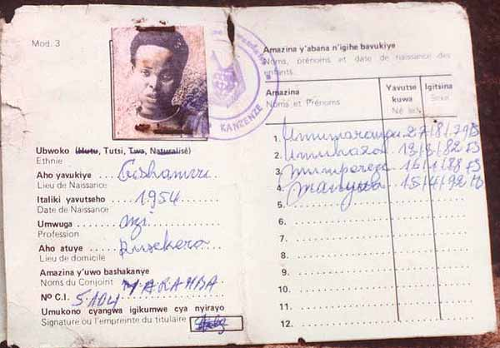
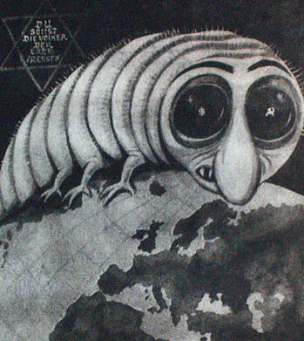
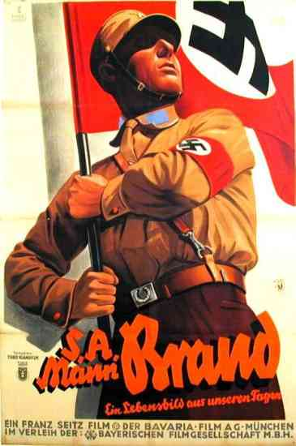
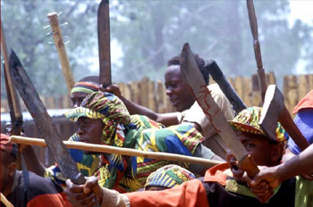

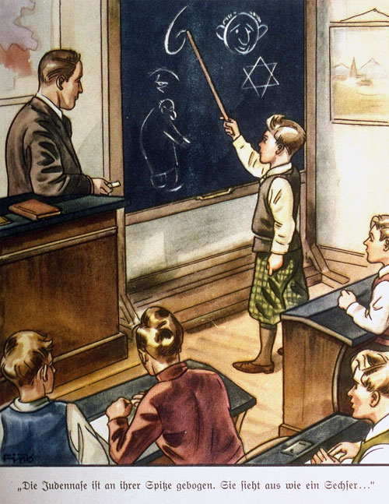
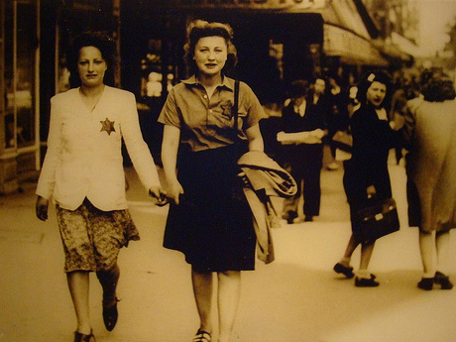
- After watching the videos of Victor and Joe, please record some specific examples of the warnings signs that our survivors discuss.
Joe Diamond and the Holocaust | Victor Habinshuti and The Rwandan Genocide

- Please classify the specific examples that Joe and Victor describe into our warning signs categories.
  - For example: Joe wearing the Star of David = Symbolization/ Group Marking and Classification.
Example | Warning Sign
Wearing Star of David | Symbolization/Group marking/Classification
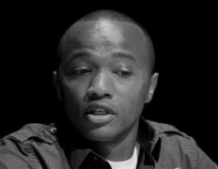

Example | Warning Sign

- Conclusion/Questions for Discussion
  - What Warning Signs did both Joe and Victor experience?
  - Are there some Warning Signs that were experienced by one survivor, but not the other?
  - Do all Warning Signs have to exist for genocide to occur?
  - If you had to rank the Warning Signs in order of biggest predictor to least likely predictor, how would you rank the Warning Signs?
  - When you recognize the Warning Signs of Genocide in your world today, what can you do to ensure that genocide does not occur?

