Comparative Analysis Worksheet 1
- Topic: Early Life
- Directions:
  - As you watch the video segments about the early life of Victor and Joe, take notes on the following topics for each survivor.
Victor Habinshuti | Joe Diamond
- Town/Neighborhood description | - Town/Neighborhood description
- Family | - Family
- Religion | - Religion
- Education | - Education
- Extras | - Extras

  - Using your notes, please fill out the Venn Diagram below to compare and contrast the early lives of Victor and Joe.
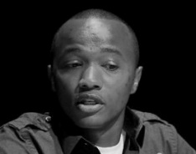
Joe
Victor

- Conclusions/Questions
  - What are some of the similarities between Victor and Joe?
  - What are some of the differences between Victor and Joe?
  - From what you have seen, do you think Victor and Joe experienced happy childhoods?
  - Please add a third circle to the diagram and fill it out with your own information.
  - How does your childhood compare to Joe’s or Victor’s early life?

